Uganda

## Political Stability Estimate Data

The data set shows the political stability estimate of the country each year.

## # A tibble: 19 x 5  
## country iso3c date stability stabilityCategory4   
## <chr> <chr> <dbl> <dbl> <chr>   
## 1 Uganda UGA 1996 -1.53 highly unstable   
## 2 Uganda UGA 1998 -1.10 highly unstable   
## 3 Uganda UGA 2000 -1.25 highly unstable   
## 4 Uganda UGA 2002 -1.42 highly unstable   
## 5 Uganda UGA 2003 -1.56 highly unstable   
## 6 Uganda UGA 2004 -1.31 highly unstable   
## 7 Uganda UGA 2005 -1.42 highly unstable   
## 8 Uganda UGA 2006 -1.14 highly unstable   
## 9 Uganda UGA 2007 -0.915 moderately unstable  
## 10 Uganda UGA 2008 -0.876 moderately unstable  
## 11 Uganda UGA 2009 -0.992 moderately unstable  
## 12 Uganda UGA 2010 -1.00 highly unstable   
## 13 Uganda UGA 2011 -0.976 moderately unstable  
## 14 Uganda UGA 2012 -0.869 moderately unstable  
## 15 Uganda UGA 2013 -0.839 moderately unstable  
## 16 Uganda UGA 2014 -0.941 moderately unstable  
## 17 Uganda UGA 2015 -0.805 moderately unstable  
## 18 Uganda UGA 2016 -0.715 moderately unstable  
## 19 Uganda UGA 2017 -0.557 moderately unstable

## Political Stability Estimate Plot

The plot shows the trends of stabilization and destabilization for the each country.

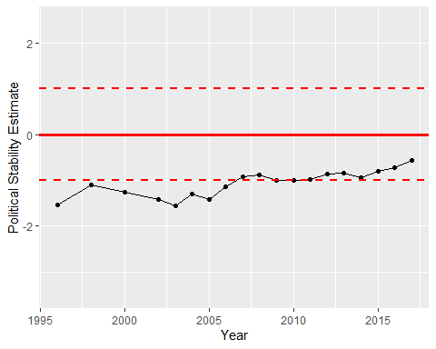

Political Stability Trend